1-2.Light up multiple colorful lights on body of robot
1.Preparation
1.You should learn about the position of the colorful lights in the body of hellobot；
2.You should learn about the micro:bit pins connected to the colorful lights in the schematic.
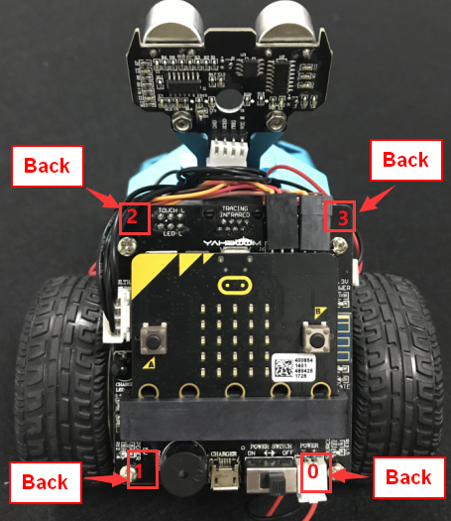
1-2-1 position colorful lights on body of hellobot（back）
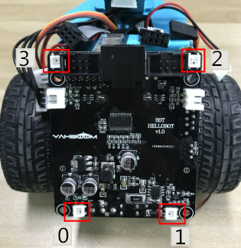
1-2-2 position colorful lights on body of hellobot
We can make different colors of light and brightness by programming.
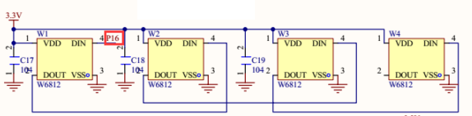
1-2-3 schematic
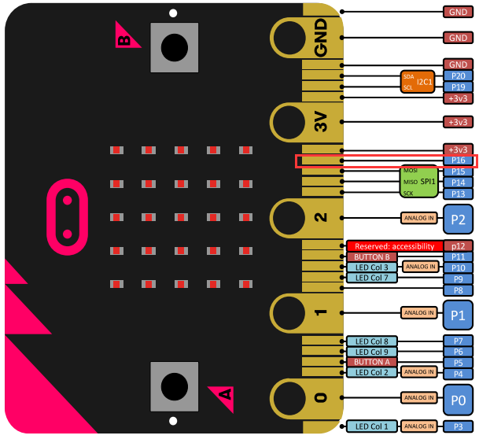
1-2-4 Pins of Micro:bit
From the schematic diagram in1-2-3, you can see that the colorful lights is connected to the P16 of the Micro:bit.
- Learning goals
In this lesson, we will learn to light up four colorful lamps in turn, the colorful lamps will emit light of different colors.
3.Programming
3.1 Programming online
You can enter the URL directly in your browser: http://python.microbit.org/v/1 to enter programming online interface.

3.2 Programming offline
1) You can double-click to use it. As shown in the following figure.

2) After entering the programming interface.
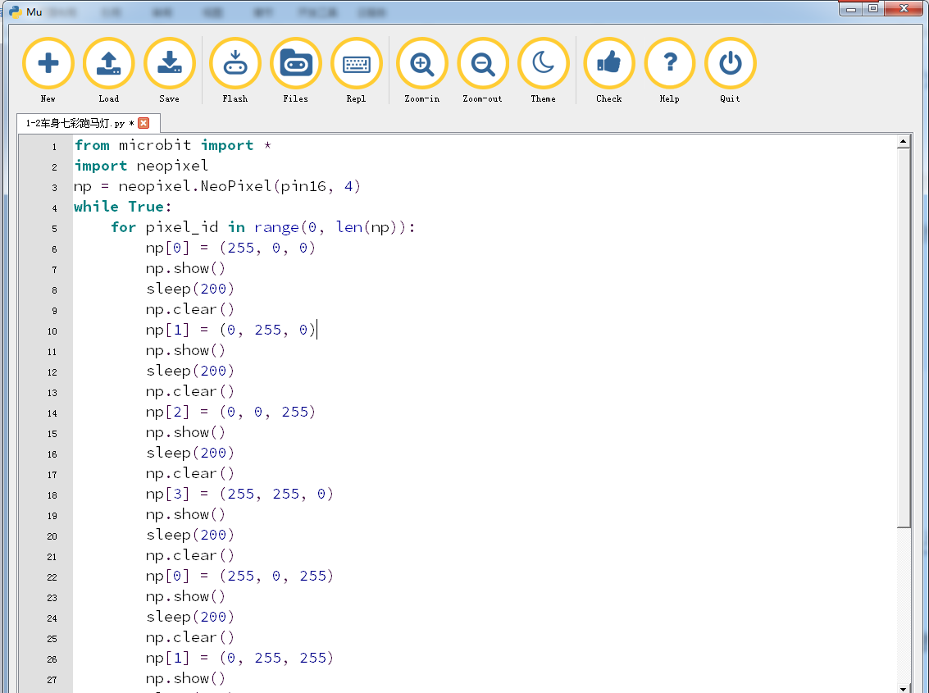
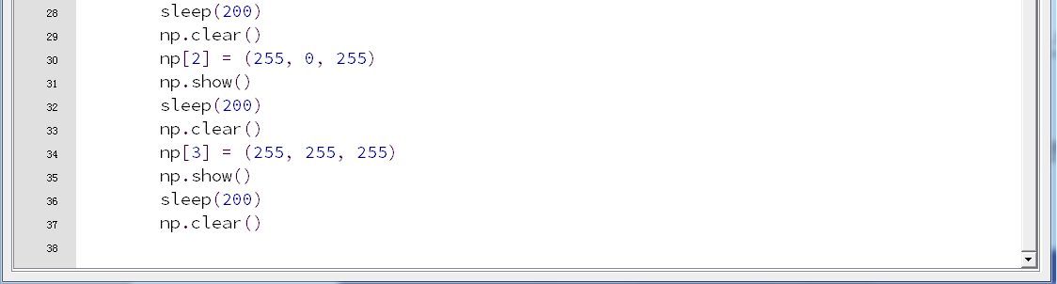
1-2-5 total program
Note:
1 - The capital letter / lowercase letters must be distinguished！
2 - Correct spelling!
3 - Keywords such as # need a space between the content.
4 - The program ends with a blank program.
5 - The block body (such as the body of the while is marked by indentation), compared to the C language, Python completely eliminates the braces (along with the semicolon of the suffix), and uses the indentation structure to represent the relationship. You can only use the Tab key (tabulation key) for indentation.
4.Download programming
You need to make sure that the micro:bit development board is connected to the computer and you need to click “Flash” button.
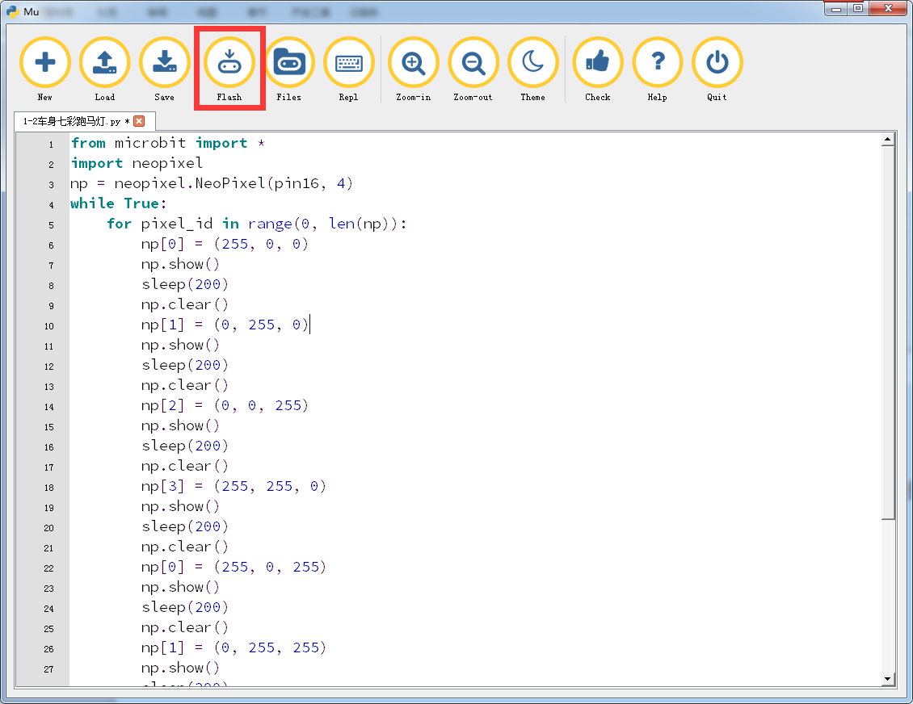
1-2-6
5.Phenomenon
After the code is uploaded. You can see that four colorful lamps are lit up in turn.
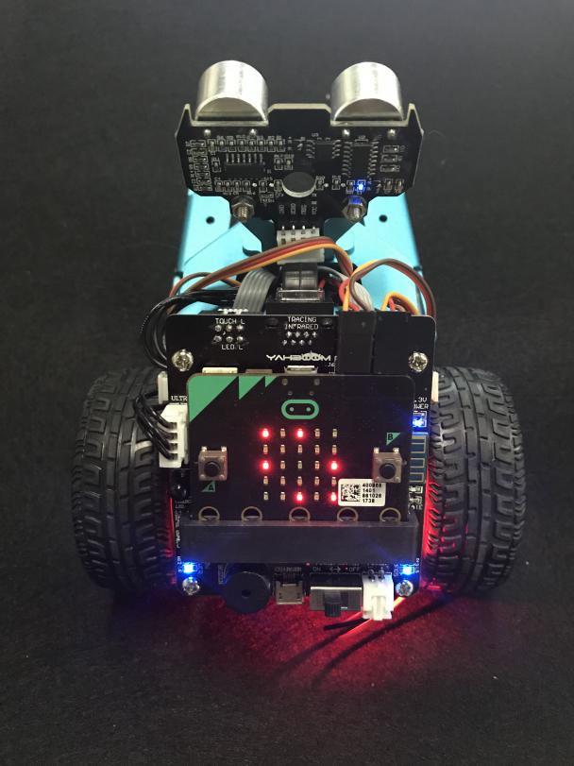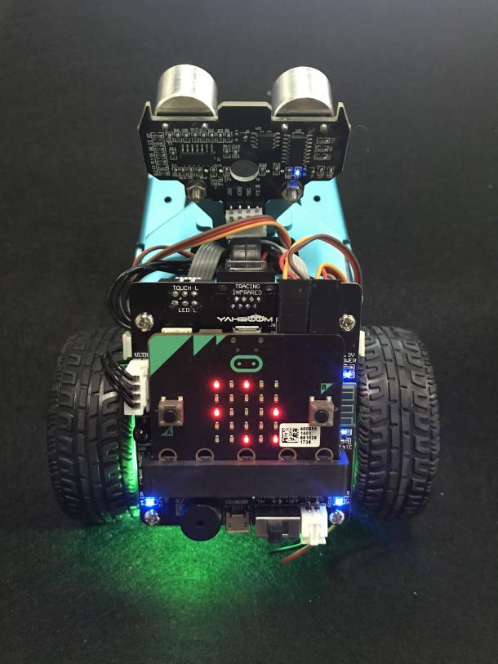
P 1-2-7 P 1-2-8
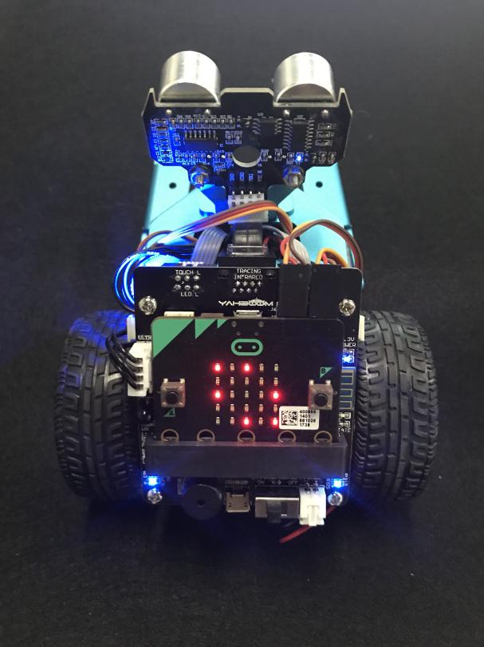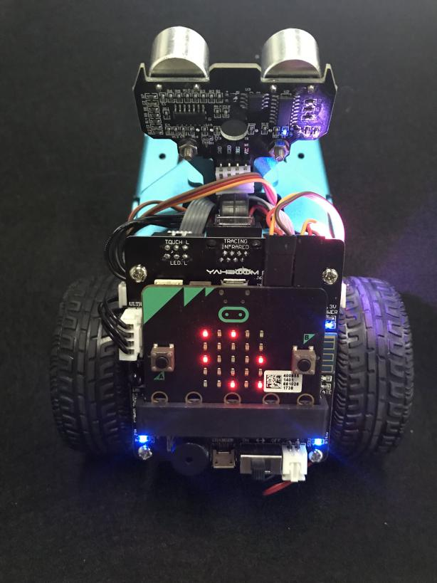
P 1-2-9 P 1-2-10

